Scaletta

Introduction
- Infant Categorization: Inizio diretto sulle due conseguenze storiche della categorizzazione (da Jones) e collegamento allo studio di essa nei bambini.
- The Robustness of Ingroup Favoritism: Il favoritismo per l'ingroup come fenomeno solido.
- The Ambiguity of Outgroup Homogeneity: L'omogeneità dell'outgroup presenta risultati ambigui nello sviluppo.
- The Multigroup Context Paradox: Plot twist: secondo diversi studi in contesti multigruppo l'ingroup viene percepito come più simile e entitativo (contrariamente ai risultati sull’omogeneità). Chi ha ragione?
- The Current Research: Esplicitazione della discrepanza teorica. Presentazione dell’MDS per mappare la categorizzazione visiva come fenomeno stabile (qua quindi ci ricolleghiamo alla categorizzazione).
- Societal Impact: Statistiche sull'immigrazione e rilevanza applicativa

Studies rationale and Hypothesis
This study examines the intersection of visual and social perception by constructing a multidimensional map of how children perceive faces across different social groups. To capture these representations, we adapted existing perceptual mapping paradigms (e.g., Moriguchi et al., 2025) into a Face Similarity Task grounded in Valentine’s (Valentine et al., 2016; Reggev et al., 2020; cit) exemplar-based Face-Space framework. Unlike norm-based models organized around a central prototype, the exemplar-based model relies on pairwise spatial relationships, where physical proximity directly reflects perceived similarity. This aligns with our premise that social groups are mentally represented through relational dynamics rather than isolated evaluations.
While face-space models have successfully demonstrated the OHE in adults—such as outgroup faces clustering more densely than ingroup faces (Papesh & Goldinger, 2010; Hart, 2021)—critical gaps remain. Prior MDS research has predominantly focused on binary ingroup-outgroup comparisons and adult populations. This dichotomous focus represents a significant methodological and ecological constraint. As highlighted in recent developmental and social literature, binary forced-choice paradigms often rely on highly prototypical exemplars, which artificially simplifies the categorization process and obscures the subtle perceptual and cultural dynamics of multiracial and multicultural environments (Dunham et al., 2015; Gedeon et al., 2021). At the same time, attempts to conduct MDS studies with child populations are present in the literature, suggesting a consistency in children’s and adults’ representations of prototypical faces (Nishimura et al., 2009). However, these studies do not focus on the categorization process; instead, they employ a norm-based approach that emphasizes face perception.
To address these gaps, the present study introduces three key innovations: applying MDS to a child sample to investigate categorization processes, expanding from binary to multi-group contexts, and focusing on relational facial dyads. To further examine categorization development as a dynamic process, we sought to test a robust perceptual effect established in the literature via MDS. Specifically, while our primary exploratory goal was to trace and visually represent developmental trajectories of categorization, our confirmatory objective aimed to test the presence of the OHE in children within a multi-group framework.

The actual project
The project comprises two independent data collections: Study 1 (S1; moderated) and Study 2 (S2; unmoderated). Both studies followed an identical core structure, with the exception of a single additional task included in the moderated version. Importantly, this supplementary task was administered at the very end of the common protocol to ensure that the unmoderated version maintained an exact structural replication of S1. The primary differences between the two versions lay in the testing environment (in-person at primary schools for S1 vs. remote online administration for S2) and the supervising adult (a trained experimenter in S1 vs. a parent or legal guardian in S2).
Drawing on established methodological frameworks (Rhodes et al., 2020; Scott et al., 2017; Scott & Schulz, 2017; Lo et al., 2023; Sheskin & Keil, 2018), this distinction can be operationalized as the difference between moderated (researcher-present) and unmoderated (researcher-absent) experimental designs. Consequently, replicating the findings of S1 holds not only theoretical but also methodological significance, as it provides evidence for the stability of the observed effects across diverse physical and social contexts. Therefore, this project aligns with an emerging line of research focused on replicating moderated, laboratory-style studies within unmoderated, online settings. The development and validation of unmoderated methodologies—which accelerated notably during the COVID-19 pandemic (Rhodes et al., 2020)—offer several key advantages, including enhanced ecological validity and the facilitation of longitudinal research designs.
Procedurally, S1 required written informed consent from parents or legal guardians prior to the testing day. Upon returning the signed consent form, children were escorted to a dedicated room within their school, where they completed the tasks supervised by an experimenter from the research team. In contrast, for the unmoderated version (S2), informed consent was obtained digitally at the onset of the online session.
Given this structural symmetry, a unified Method section is presented for both studies. Importantly, the present manuscript does not detail the hypotheses and results regarding the Trait Attribution Task (administered only in S1). This measure was originally included to address study-specific aims. To maintain narrative clarity and focus on the primary goal of the current article, the replication between S1 and S2 and the theoretical importance of stability in children's social categorization, this task was omitted from the main text. However, all hypotheses, analyses, and figures concerning the Trait Attribution Task are publicly available on the project’s GitHub repository. The hypotheses for the current investigation are as follows:
H1: Outgroup Homogeneity Effect (OHE)
H1a: Based on Jones et al. (1981), we expect participants to successfully visually discriminate individual minority outgroup faces, yet perceive members within each outgroup as significantly more similar to one another compared to ingroup members.
H1b: No significant differences in the magnitude of the OHE are expected as a function of participants’ gender.
H1c: The magnitude of the OHE is expected to decrease as a function of age.

H2: Minority Groups Homogeneity Effect (MGHE)
H2a: Following Tepper and Gilovich (2024), we expect majority group participants (Italians) to perceive less similarity between images of ingroup members (an intragroup comparison) than between members of two distinct minority outgroups (an intergroup comparison).
H2b: No significant differences in the magnitude of the MGHE are expected as function of participants’ gender.
H2c: The magnitude of the MGHE is expected to decrease as a function of age.

Openness and Transparency Note
This study was conducted in accordance with the principles of the Declaration of Helsinki. Ethical approval was granted by the Ethics Committee of the University of Padua (Protocols:). Data analyses were performed using R (cit) within the RStudio environment (Posit team, 2025). Definire analisi e pacchetti una volta scritta la parte relativa.
Both studies were preregistered on the OSF (Open Science Framework). The pre-registration for S1 can be accessed at (link 1), and the pre-registration for S2 is available at (Link 2). The results section follows the main preregistered hypotheses. Additionally, reflecting the exploratory nature of this study, we further investigate specific exploratory hypotheses that were also included in the pre-registration. To ensure full reproducibility, all analytic code required to reproduce the reported results, along with the experimental protocol, raw data, and processed data, are publicly available at the following GitHub links: LINK for S1, LINK for S2.

Method

Materials
The study was programmed in JavaScript using the jsPsych library (Version 7.3.4) and hosted for online administration via the Pavlovia platform (cit?). To enhance participant engagement, the experimental tasks adopted a gamified approach, structured as an interactive adventure in which the Lab’s mascotte, Oscar the meerkat, guided the participants throughout the procedure. The specific details of the storyline, briefly outlined below, are available in their entirety on GitLab alongside the experimental code (link in GitHub).

Preparing the Face Similarity Task
To prepare the Face Similarity Task, we selected 40 (20 female stimuli and 20 male stimuli) artificial intelligence-generated faces (via Gemini Pro Nano). These stimuli, presented with a realistic oval mask that blurred and cropped the hair to ensure uniform face and hairline dimensions, were standardized for similarity using FaceNet embeddings and controlled for emotional neutrality. Full details of the image selection process are available in the project’s GitHub repository. These faces represented four distinct ethnic groups (five faces per group): African descent, East Asian, South American, and Northern Italian. During stimulus selection, varying levels of specificity were considered; specifically, it was crucial to ensure that the Caucasian faces would be perceived as the ingroup by the majority-group participants. The remaining groups were selected based on the existing literature, aligning with the other ethnic-categorization studies (e.g., Paul et al., 2022; Caharel et al., 2011).
The total design grid comprised 190 possible face combinations, which would have required an excessive number of trials per participant, thereby increasing the task's cognitive load and duration. Following established literature, we implemented an incomplete block design. Consequently, each participant evaluated 66 face pairs. By reducing the initial grid size, we ensured the task duration remained within acceptable limits for children. Furthermore, as this design resulted in a 2.88 probability of each comparison being viewed by a given participant, we adjusted our target sample size accordingly (as defined in the power analysis section).

Procedure and Measures
The main sections were structured as follows.
- Sociodemographic section. The initial section was completed alongside the experimenter in S1 or the legal tutor in S2. Indeed, the questions were directed to them. Additionally, in S2 brief instructional slides were presented to parents regarding the study procedures and the level of guidance to provide the child with. In the moderated version, this information was communicated directly to the experimenters prior to the start of data collection.
The three key items of the socio-demographic section concerned the participant’s ethnic background, age, and gender. While the first two questions were essential for evaluating exclusion criteria, the last was fundamental to expose participants exclusively to faces matching their own gender. Distinguishing gender ingroups from outgroups is highly relevant in perceptual judgments, as gender serves as a primary social category that is rapidly and spontaneously extracted, directly modulating subsequent face-processing and recognition mechanisms (Hugenberg et al., 2010; Timeo et al., 2017). Accordingly, the demographic query regarding gender utilized a binary choice that triggered a branching logic rule within the survey. As a result, participants only evaluated the set of faces that matched their reported gender. Furthermore, an exploratory visual self-categorization item was included in this section. Participants were presented with four faces (one randomly drawn from each of the four ethnic groups) and were asked "Click the face that you consider as most similar to yours" (original Italian: "Clicca sulla faccia che secondo te ti somiglia di più").
- Gamified training and instructions. This section introduced the gamified narrative and the part deliberately designed for the children. Oscar the meerkat presented himself in the first person, explaining that, as a meerkat lacking expertise in distinguishing human faces, he needed the participant's help to learn how to differentiate them. Importantly, throughout the entirety of the study, there was no reference to social or ethnic groups. The participant was always asked to evaluate the similarity of faces of children. Through this first sociodemographic branching we were able to control two of the three main categories relevant in childhood (Bigler & Liben, 2006; Brewer, 1988; Kinzler et al., 2010; Shriver et al., 2008), and to focus on the third category: ethnicity. This particular allows for the study of spontaneous categorization, rather than imposed and explicit categories. After this block, the instructions of the Face Similarity Task (FST) were presented, detailing the response labels and forewarning the potential appearance of an attention check. Subsequently, to confirm the child's comprehension of the task and to familiarize them with the presentation speed of the stimuli, a brief training block consisting of two trials was administered. Upon completion of this block, a checkpoint screen was displayed to the accompanying adult to verify the child's understanding of the procedure and the task. If comprehension was confirmed, the experiment advanced; if not, the training block could be repeated. Throughout this phase, the experimenter and tutors were instructed to accommodate the participants' needs by reading text aloud and addressing any questions the children had regarding the task or the use of the computer.
- Face Similarity Task. As previously described, in this task participants were presented with all pairwise combinations generated from a final subset of 12 images (three per ethnic group), which were randomly selected from an initial pool of 20 (five per group). Each participant viewed a total of 66 face dyads, administered across two blocks with a break in the middle. On each trial, two faces were presented in randomized positions along the circumference of an imaginary circle, following the paradigm of previous visual perception tasks (e.g., Moriguchi et al., 2025). The sequence and timing of the trials were standardized. Specifically, each trial began with the presentation of a fixation cross (800 ms), followed by the target stimuli (1,000 ms). Subsequently, participants were presented with the prompt “How similar are they?” (original Italian: “Quanto si somigliano?”) and were asked to provide their rating on a 4-point scale ranging from “Very dissimilar” (0) to “Very similar” (3). Detailed information regarding the development of the FST, the code, and the mathematical specifications concerning the number of images and comparisons is available in GitHub.

Participants
Sample Size. As outlined in the preregistered protocol, sample size determination was guided by a unified analytical pipeline designed to ensure adequate power across all experimental procedures. To determine the required sample size, an a priori power analysis for bivariate correlations was conducted using the “pwr” package in R (Champely, 2020). For S1, the analysis indicated that a target sample of N = 194 was required to detect a small-to-medium effect size (r = .20) with 80% power at α = .05. The preregistration established this correlational test—originally tied to trait attribution hypotheses (H3-H5) omitted from the present manuscript to maintain focus on perceptual representations—as the analytical bottleneck of the entire study. Retaining this target of N = 194 served as a highly conservative benchmark, inherently guaranteeing that the primary tests retained in this manuscript (i.e., MDS and Linear Mixed Models) would safely exceed their minimum preregistered threshold of N = 120 (60 participants per group).
Concurrently, the incomplete block design utilized for the 20 x 20 dissimilarity matrices required sufficient cell density for accurate spatial reconstruction. Previous MDS literature suggests that a minimum of 7 evaluations per matrix cell is acceptable (Davison & Sireci, 2000), whereas contemporary empirical standards aim for higher coverage (~ 20 evaluations per cell;(Correll et al., 2025).
Accordingly, for S1, the recruitment goal was set to N = 194, corresponding to a target average density of 20.8 evaluations per matrix cell (details and exclusions for S1 are reported in the Final Sample section below). For S2, although the preregistered target was N = 120, the final unmoderated sample comprised N = 101 participants (n ≈ 50 per stimulus condition). Despite being lower than the initial goal, this sample size yielded an average density of 17.3 evaluations per cell. Diagnostic checks confirmed consistent coverage across target conditions (Male targets: M = 17.0, range = 8-24, median = 17; Female targets: M = 18.1, range = 6-27, median = 18), ensuring a robust empirical foundation for both studies.

Final samples
Data collection procedure. Data collection was conducted in presence in eight schools across four different regions in Italy (i.e., Emilia-Romagna, Friuli-Venezia Giulia, Tuscany, and Veneto). To maintain a structure comparable to the unmoderated S2, a standardized experimental protocol was implemented across all participating institutions. This protocol encompassed both environmental guidelines and task-related procedures. Composition. In both S1 and S2the primary pre-registered inclusion criteria were based on participant age and ethnic background. The age range was restricted to 3 to 8 years to begin delineating a developmental trajectory of the effect. Regarding ethnic background, we only included participants who selected either “Italian” or “other European country” in the sociodemographic section. Furthermore, two pre-registered attention checks were implemented. The first check explicitly instructed participants on which number to press on the screen during the FST; participants who failed to press key 3 (i.e., very similar) were excluded. The second check involved the exclusion of participants who exhibited zero variance in their responses across the FST.
Additionally, only in S1, the experimenters overseeing the task and ensuring participants' well-being reported certain cases that required manual exclusion (via hardcoding) for unanticipated reasons, including participant withdrawal (dropout), clinical diagnoses, explicit difficulties in understanding the FST, and inattention. Full details regarding these specific exclusions can be found in the script in the GitHub repository.
In S1 the final valid sample comprised 249 participants (M = 5.17 years, SD = 1.23, range = 3–8 years). The age distribution of the sample was as follows: 3-year-olds (n = 18), 4-year-olds (n = 66), 5-year-olds (n = 61), 6-year-olds (n = 71), 7-year-olds (n = 25), and 8-year-olds (n = 8). The sample included 134 boys (53.8%) and 115 girls (46.2%). Regarding ethnic background, 239 participants (96%) were of Italian origin, and 10 (4%) were from other European countries.
As for S2, in total, the final valid sample comprised N = 101 participants (M = 6.06 years, SD = 1.43, range = 3–8 years), consisting of 52 girls (51.5%) and 49 boys (48.5%). Regarding ethnic background, 100 participants (99.0%) were of Italian origin, and 1 participant (1.0%) was from another European country. The age distribution was as follows: 3-year-olds (n = 2), 4-year-olds (n = 15), 5-year-olds (n = 23), 6-year-olds (n = 16), 7-year-olds (n = 25), and 8-year-olds (n = 20).

Study 1 - moderated

Results
H1A. To evaluate H1A at a descriptive and spatial level, the three-dimensional coordinates generated by the MDS (Figure 1) algorithm were analyzed.

Figure 1
Three-Dimensional MDS Configurations for Female and Male Face Stimuli, Study 1
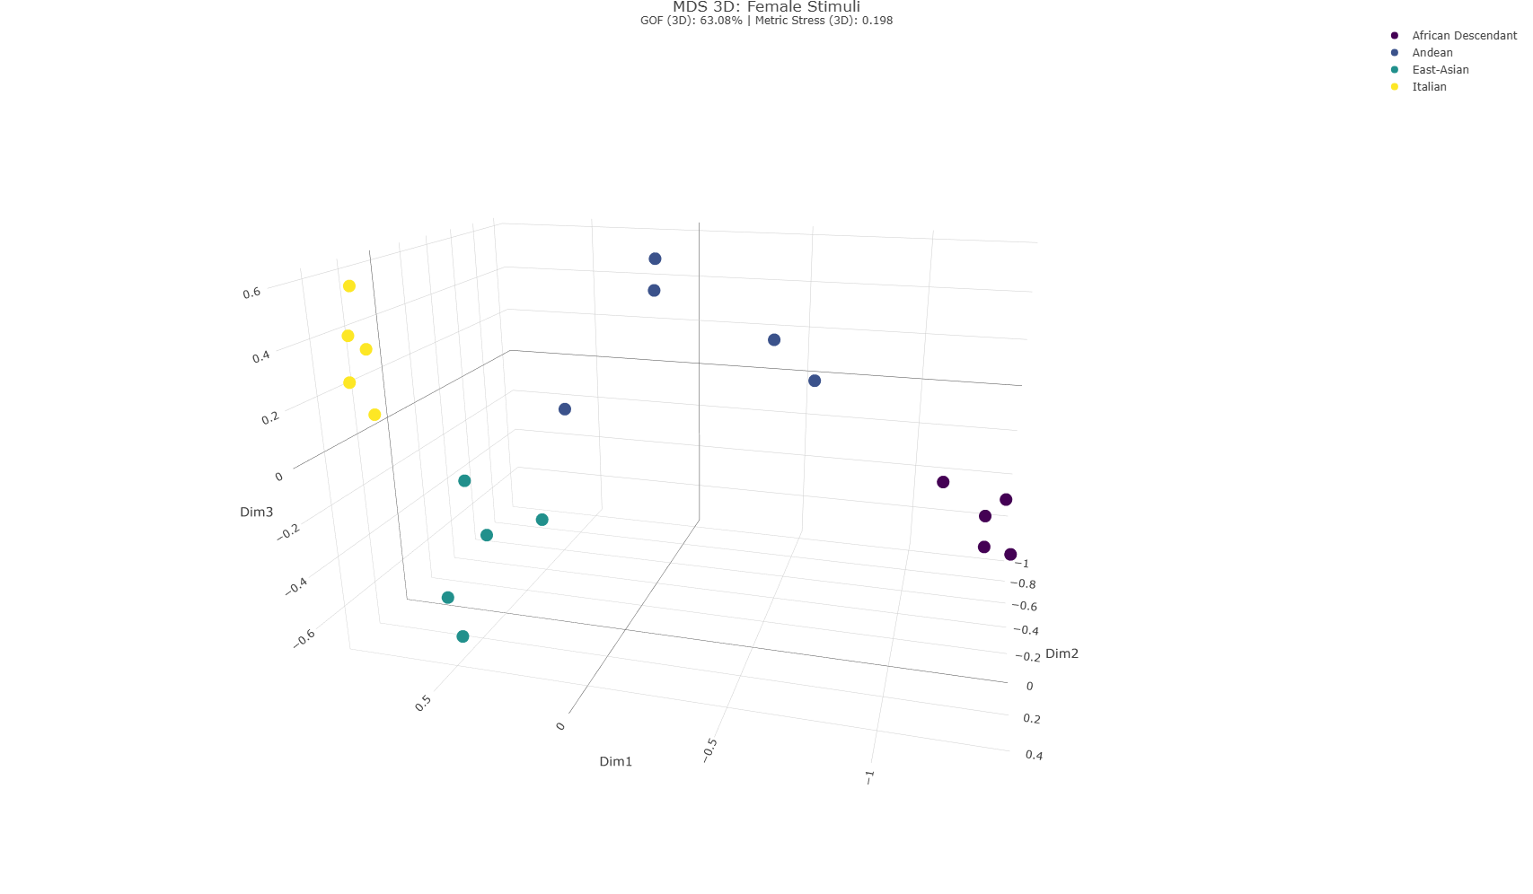
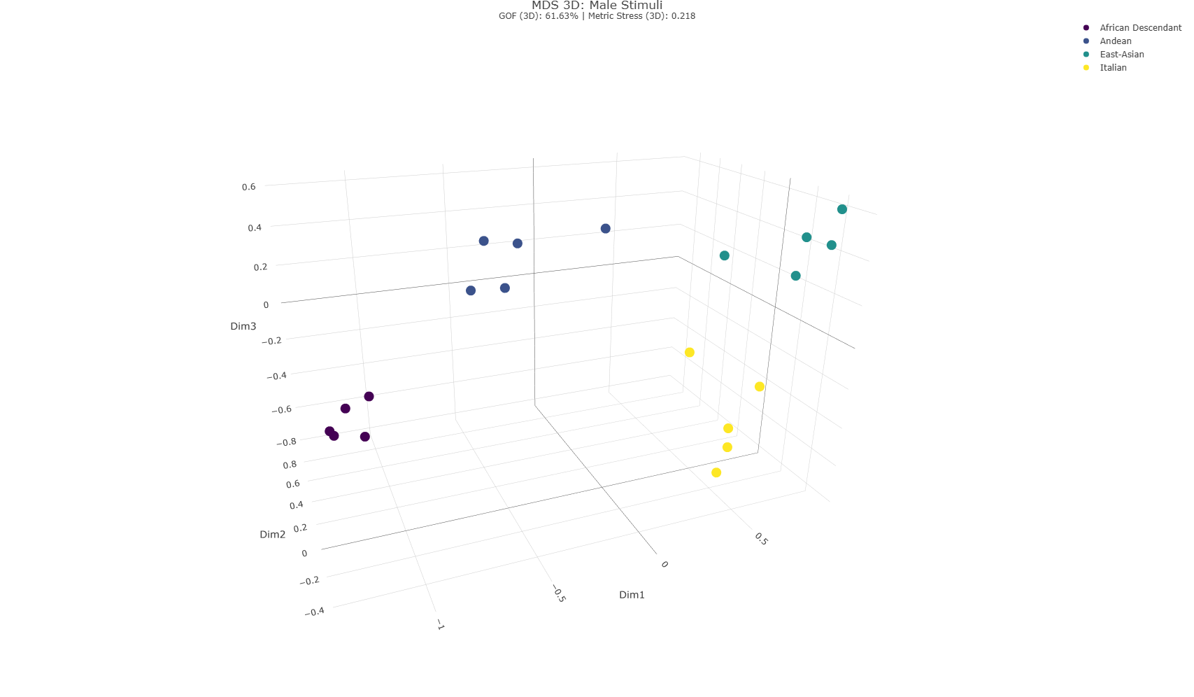
Note. Spatial representations derived from the 3D MDS analysis for female (top panel) and male (bottom panel) stimuli. Individual data points represent isolated faces, color-coded by target group: African Descendant (purple), Andean (dark blue), East-Asian (teal), and Italian (yellow). The female stimuli model demonstrates a Goodness of Fit (GOF) of 63.08% with a Metric Stress of 0.198. The male stimuli model demonstrates a GOF of 61.63% with a Metric Stress of 0.218. Full interactive plots are available in the GitHub repository.
Specifically, two spatial indices of concentration were measured and compared: the volume of the ellipsoid encompassing 95% of the variance (see Figure 2) and the volume of the minimum convex hull bounding the five stimuli for each group. Both indices are expressed in cubic Euclidean spatial units, which are proportional to the mean distances perceived by participants on the original 0 to 3 scale.
Contrary to the predictions, the spatial results did not reveal a systematic pattern of greater homogeneity (smaller volume) for the outgroups compared to the Italian ingroup across stimulus genders. For female stimuli, the largest dispersion volume was observed for the Andean group (volume = 2.50), followed by the East Asian group (volume = 0.30), whereas the Italian ingroup (volume = 0.04) and the African Descent group (volume = 0.05) exhibited markedly smaller and comparable spatial volumes. For male stimuli, the Italian ingroup showed the largest spatial dispersion (volume = 0.35), followed by the Andean group (volume = 0.27), while the African Descent (volume = 0.05) and East Asian (volume = 0.03) groups displayed highly concentrated volumes. The minimum convex hull volume analysis fully confirmed these spatial proportions across both genders. Overall, the descriptive geometric 3D data did not support the OHE theory that faces of each outgroup are systematically perceived as spatially more homogeneous than same-ingroup faces.

Figure 2
Ellipsoid Volume by Stimulus Group and Gender
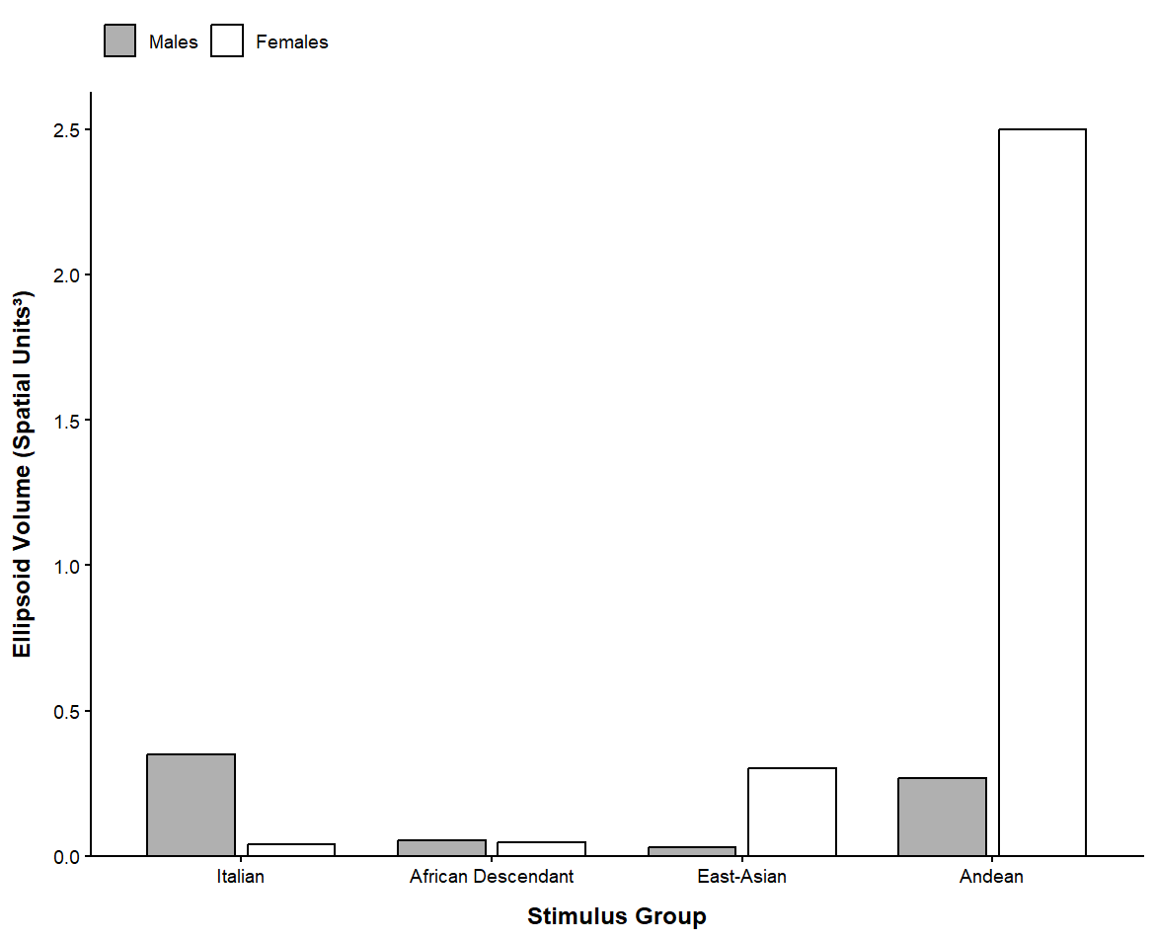
Note. Bar chart of 3D MDS ellipsoid volumes (Euclidean units³) across the four stimulus groups. Gray bars indicate male stimuli; white bars indicate female stimuli.

H2A. To spatially test H2a, as preregistered, the centroid (i.e., the geometric center of the five points for each group) was utilized as the key metric in three-dimensional MDS space. Adopting this parameter allowed for testing whether the outgroup centroids were closer to one another than to the majority ingroup centroid. Distances between the centroids of different groups are presented in Table 1. As shown, the outgroups were not closer to one another than they were to the ingroup. The African Descent group was the most distant from all other groups across both male stimuli (M = 1.87) and female stimuli (M = 1.86). This outcome aligns with the overall three-dimensional MDS solution, indicating no general tendency to perceive ethnic outgroups as closer to one another.

Table 1
3D Centroid Distances for Male and Female Stimuli
Stimulus Gender | Group | 1 | 2 | 3 | 4
Male | 1. African Descent | —
 | 2. East Asian | 2.056 | —
 | 3. Italian | 1.984 | 1.017 | —
 | 4. Andean | 1.559 | 1.463 | 1.367 | —
Female | 1. African Descent | —
 | 2. East Asian | 1.966 | —
 | 3. Italian | 2.067 | 1.031 | —
 | 4. Andean | 1.554 | 1.212 | 1.384 | —
Note. Values indicate the 3D MDS centroid distances between the four stimulus groups in Euclidean units³.

As these values suggest, the participating children, across both male and female stimulus sets, tended to share a common spatial mapping. In relation to the study's primary objective of investigating social categorization in childhood, this finding holds significance and provides a baseline for hypotheses regarding the role of age. To explore this similarity, given the centrality of the ingroup and the importance of examining how outgroups were perceived by ingroup members, Figure U demonstrates a consistent perceptual pattern across both stimuli targets regarding the distance between the ingroup and the three outgroups. Specifically, East Asian stimuli were perceived as most similar to the Italian ingroup, whereas African Descent stimuli were perceived as most distant. This corroborates the presence of a shared strategy for social categorization and face-pair differentiation and allows us to move to statistical operationalization.

Figure 3
3D MDS spatial distance of minority-group centroids from the majority-group centroid
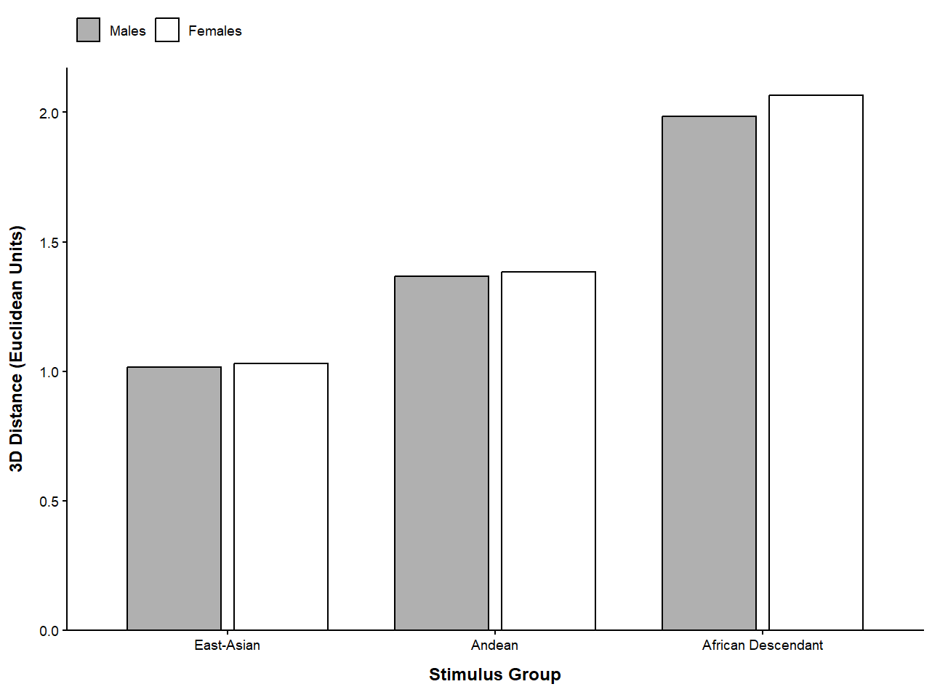
Note. 3D MDS spatial distance of minority centroids from the Italian centroid in Euclidean units³.

Statistical analysis
Although Multidimensional Scaling (MDS) provides a descriptive spatial representation of ethnic categorization, and it allows us to suggest that participants used common criteria to categorize the displayed comparisons, it assigns single coordinates to individual stimuli and cannot inferentially test the pairwise comparisons. Because the experimental task required participants to evaluate dyads, these direct comparisons were analyzed in Rstudio (Posit Team, 2026) using a Linear Mixed Model (LMM; Bates et al., 2015; Kuznetsova et al., 2017). The dependent variable was the perceived distance for each dyad. To test the preregistered hypotheses, dyads were classified into a four-level predictor based on their group relationship:
- In-In: Two majority ingroup faces.
- Out-Out: Two faces from the same minority outgroup.
- In-Out: One ingroup face and one outgroup face.
- Out1-Out2: Two faces from different outgroups.
To evaluate the developmental trajectories of perceptual biases (H1C and H2C), the model estimated the main interaction between the dyad category and participants' age (mean-centered to facilitate intercept interpretation). Participant gender was included as a control covariate. To account for variance associated with repeated measures and stimulus idiosyncrasies, crossed random intercepts were specified for participants and the individual images (left and right stimuli). Omnibus significance was assessed using a Type III ANOVA (Fox & Weisberg, 2019). To directly test H1 (Outgroup Homogeneity Effect) and H2 (Minority Groups Homogeneity Effect), Estimated Marginal Means (EMMs; Lenth & Piaskowski, 2026) with 95% confidence intervals were computed to conduct planned contrasts among the In-In, Out-Out, and Out1-Out2 categories. Furthermore, age slopes were extracted for each dyad category to quantify how the magnitude of these homogeneity effects shifted across development.
H1A and H2A. The baseline category for group relationship was set to ingroup dyads (In-In). At average age, perceived distance for baseline In-In dyads was significantly greater than zero, b = 0.88, SE = 0.14, t(81.1) = 6.49, p < .001. Compared to In-In dyads, perceived distance was significantly larger for In-Out dyads, b = +0.79, SE = 0.07, t(95.4) = 10.74, p < .001, and Out1-Out2 dyads, b = +0.81, SE = 0.13, t(66.1) = 6.09, p < .001. In contrast, perceived distance for Out-Out dyads did not differ significantly from In-In dyads, b = -0.01, SE = 0.13, t(65.9) = 0.10, p = .922. This is different from our predictions about outgroup homogeneity (H1A) and minority-groups homogeneity (H2A). The overall effect was also assessed by running a Type III ANOVA (Intercept: χ²(1) = 42.14, p < .001). The result confirms that the type of relation between the two compared faces was significant, χ²(3) = 801.34, p < .001.
Planned contrasts support the idea that the difference between the In-In and Out-Out (represented in Figure 4) dyads was not significant (b = -0.01, SE = 0.13, z = -0.11, p = 1.000), while the difference between the Out-Out and Out1-Out2 dyads was significant (b = -0.80, SE = 0.04, z = -21.49, p < .001).
Furthermore, highlighting the underlying categorization processes, participants readily differentiated faces across two distinct ethnic groups, but failed to do so for faces within the same group.
Figure 4
Perceived Distance by Category Dyad
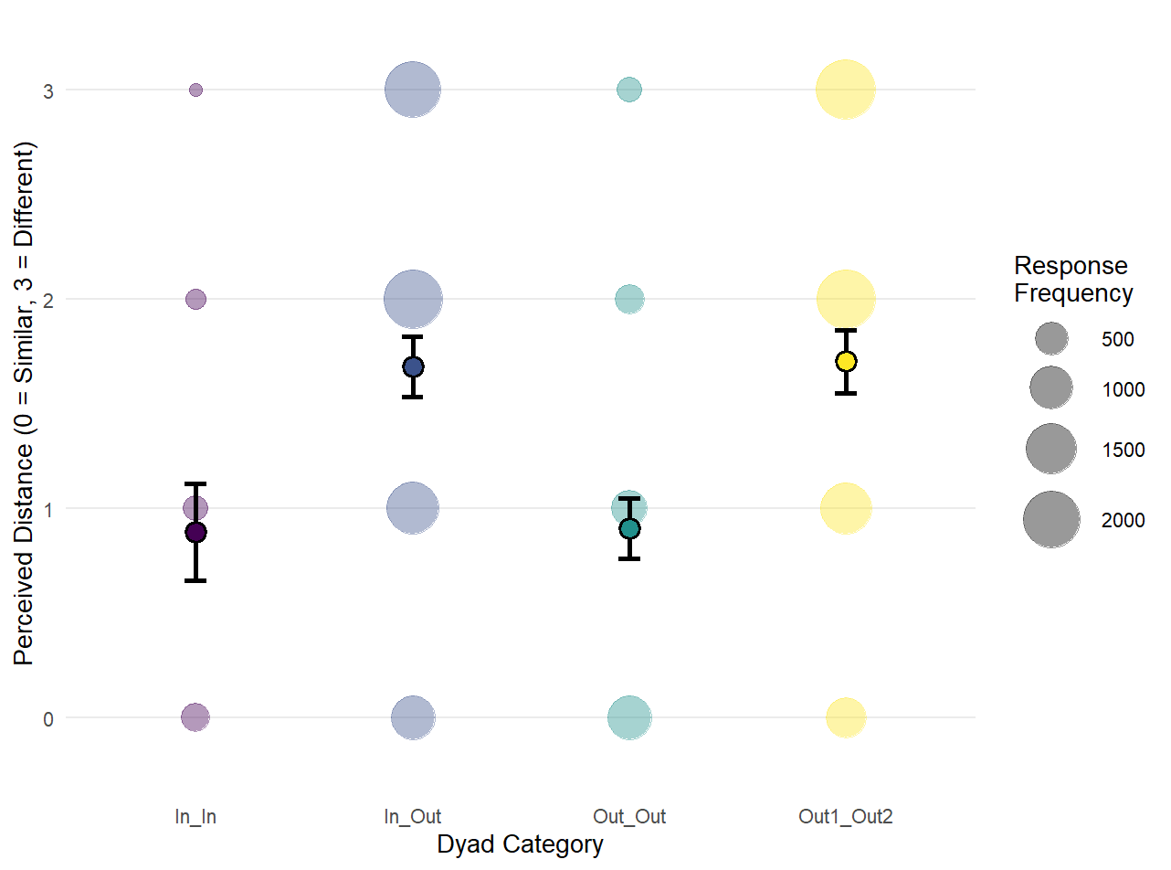
Note. Bubble plot displaying perceived distance ratings across four dyad categories. The size of each colored bubble corresponds to the response frequency for that specific rating. Solid points represent the mean perceived distance for each category, and error bars denote 95% confidence intervals
H1B and H2B. As predicted by H1B and H2B, participant gender yielded no significant main effect, b = 0.03, SE = 0.13, t(71.3) = 0.20, p = .845. This observation is also supported by the Type III ANOVA, χ²(1) = 0.01, p = .84.
H1C and H2C. Regarding developmental effects, the age interaction for In-In dyads was not significant, b = 0.01, SE = 0.03, t(1809.0) = 0.29, p = .774. However, a significant interaction emerged between age and the Out1-Out2 dyad category, b = 0.07, SE = 0.03, t(16250.0) = 2.44, p = .015, indicating that perceived distance between different outgroup members increases more steeply with age relative to same-ingroup comparisons. The interaction between age and In-Out dyads showed a non-significant trend, b = 0.05, SE = 0.03, t(16240.0) = 1.85, p = .064, similarly to the interaction for Out-Out dyads, b = -0.05, SE = 0.03, t(16260.0) = -1.54, p = .124.
Although these values are informative of the relationship between different dyads slopes with the ingroup’s dyad slope, they don’t answer the question made by H1C and H2C on the role played by age. To assess these, the preliminary value of the Type III ANOVA confirmed an interaction between the dyad type and the age, Type III ANOVA, χ²(3) = 46.47, p < .001.
To further probe this interaction, Estimated Marginal Trends (EMTs) were calculated. This analysis allowed for an independent examination of the developmental trajectory of perceived distance within each dyad category (see Figure 5 for a visual representation). Specifically, the results indicated that for both inter-group dyads, In-Out (b = 0.06, SE = 0.02, 95% CI [0.02, 0.11]) and Out1-Out2 (b = 0.08, SE = 0.02, 95% CI [0.04, 0.12]), perceived distance changed significantly as a function of age. In other words, when exposed to faces belonging to two different groups, older children tended to rate them as more dissimilar compared to younger children. Conversely, age did not significantly affect perceived distance for intra-group comparisons, namely the In-In (b = 0.01, SE = 0.03, 95% CI [-0.06, 0.08]) and Out-Out (b = -0.04, SE = 0.03, 95% CI [-0.09, 0.01]) dyads.
These findings do not confirm either the OHE or the minority-groups homogeneity effect. Rather, they support the previously discussed baseline findings regarding common perceptual mapping, suggesting that children not only perceive social categories but also increasingly differentiate between distinct social groups as they grow older.
Finally, as an additional analysis, a granular model was also computed to investigate whether specific groups were driving the effect. For the sake of brevity, these results are available in the GitHub repository.

Figure 5
Developmental Trajectories. Interaction Between Dyad Categories and Age
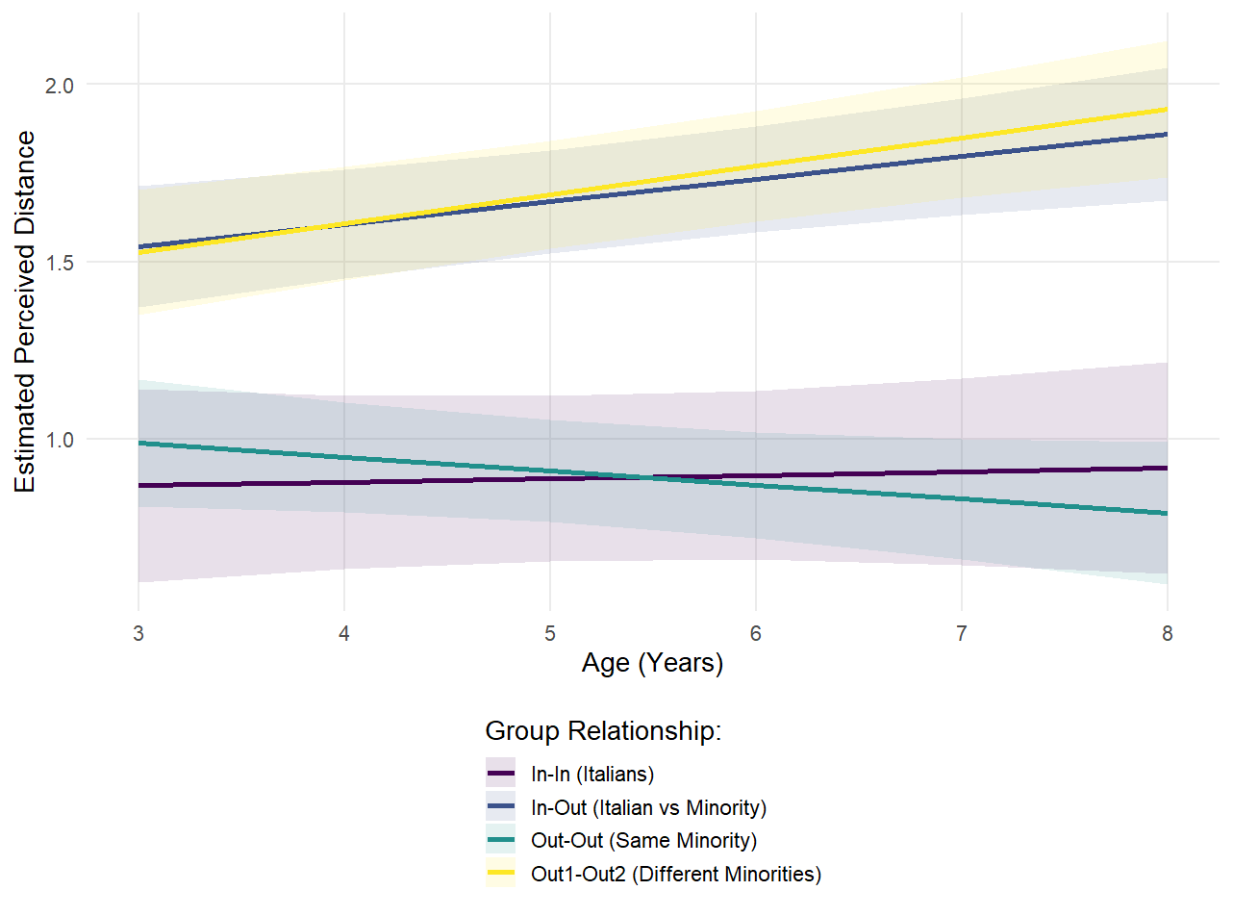
Note. Trajectories of perceived distance between two faces across participants’ age for the four dyadic categories. The slopes represent the group relationships: In-In (purple), In-Out (dark blue), Out-Out (teal), and Out1-Out2 (yellow). Shaded bands around the regression lines indicate 95% confidence intervals.

Study 1 Discussion

- Interpretazione dei risultati soprattutto facendo all’effetto dell’età sullo sviluppo .

Study 2 - Unmoderated
Results

Spatial Analysis (Multidimensional Scaling)

H1A. To evaluate H1A at a descriptive and spatial level, the three-dimensional coordinates generated by the MDS algorithm (in Figure 6; full report of spatial structure to the interpretation of 2D and 3D models on the GitHub repository) were analyzed using the same spatial indices of concentration employed in S1: the 95% confidence ellipsoid volume and the minimum convex hull volume.

Figure 6
Three-Dimensional MDS Configurations for Female and Male Face Stimuli, Study 2
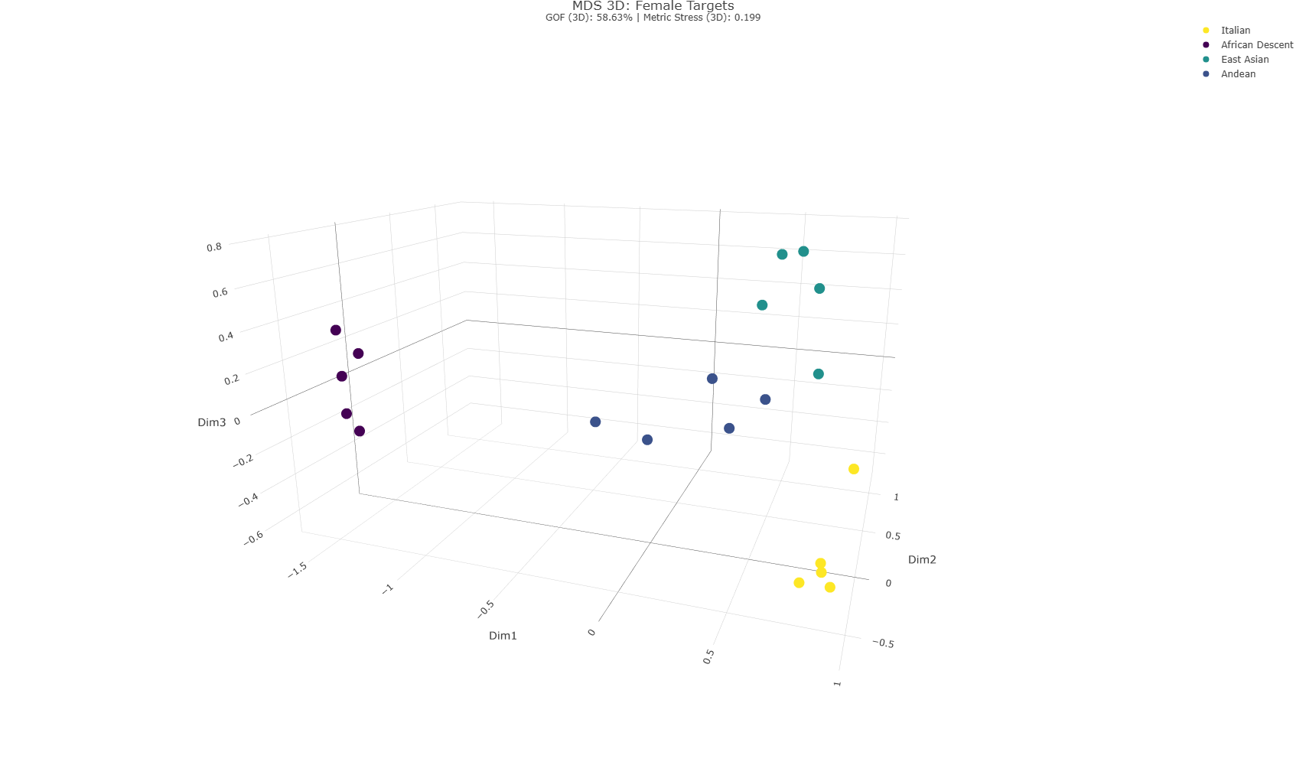
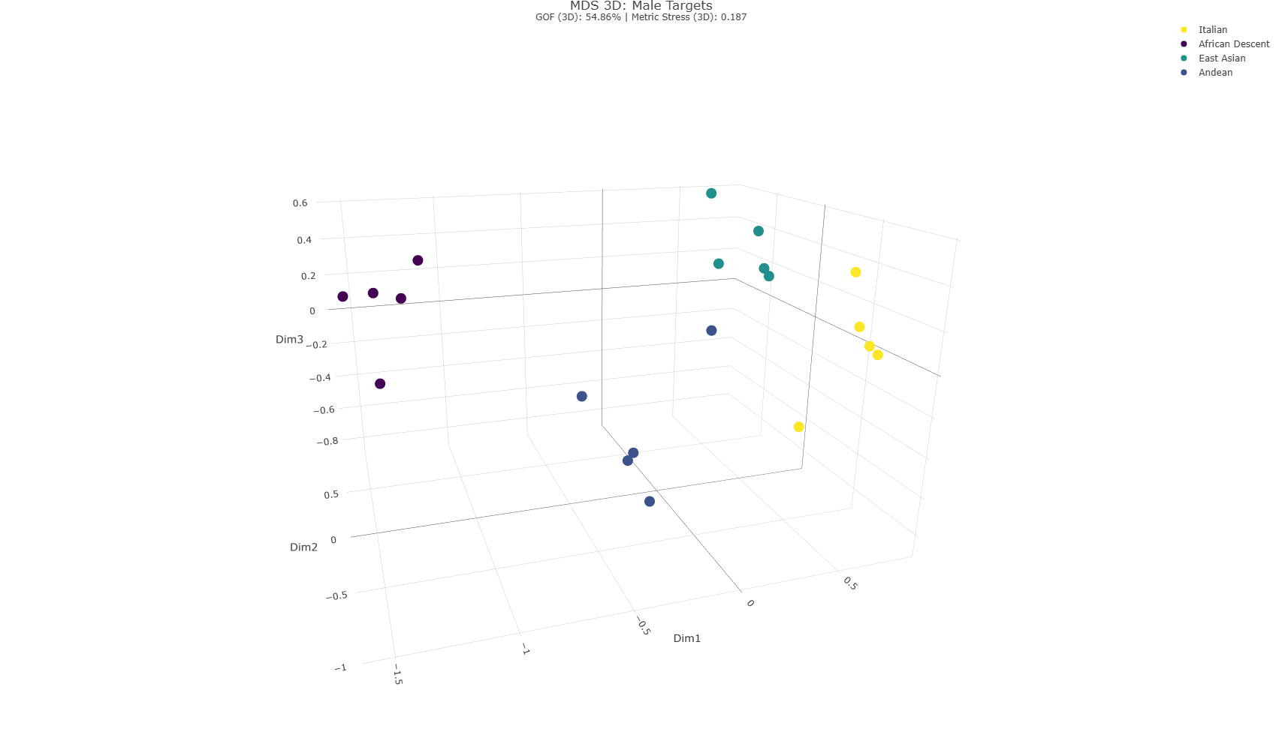
Note. Spatial representations derived from the 3D MDS analysis for female (top) and male (bottom) stimuli. Individual data points represent isolated faces, color-coded by target group: African Descendant (purple), Andean (dark blue), East-Asian (teal), and Italian (yellow). The female stimuli model demonstrates a Goodness of Fit (GOF) of 58.63% with a Metric Stress of 0.199. The male stimuli model demonstrates a GOF of 54.86% with a Metric Stress of 0.187. Full interactive plots are available in the GitHub repository.

Consistent with the results of S1, the spatial results for S2 (in Figure 7) did not support the hypothesis of a systematic outgroup homogeneity effect (H1A).
For female stimuli, S2 closely replicated the structural pattern observed in S1: the Andean group again exhibited by far the largest dispersion volume (volume = 1.50), followed by the East Asian group (volume = 0.14). The Italian ingroup (volume = 0.12) and the African Descent group (volume = 0.06) displayed the most concentrated spatial configurations.
For male stimuli, the pattern diverged slightly from S1 but similarly failed to support H1A. While S1 identified the Italian ingroup as the most spatially dispersed, S2 revealed that the Andean (volume = 0.39) and African Descent (volume = 0.34) groups occupied the largest spatial volumes. The Italian ingroup (volume = 0.21) and the East Asian group (volume = 0.20) exhibited smaller levels of dispersion. Across both genders, the minimum convex hull volume analysis supported these geometric proportions. Overall, the descriptive 3D spatial metrics in S2 replicate the conclusions of S1: faces belonging to outgroups are not systematically perceived as spatially more homogeneous than same-ingroup faces.
Figure 7
Ellipsoid Volume by Stimulus and Gender
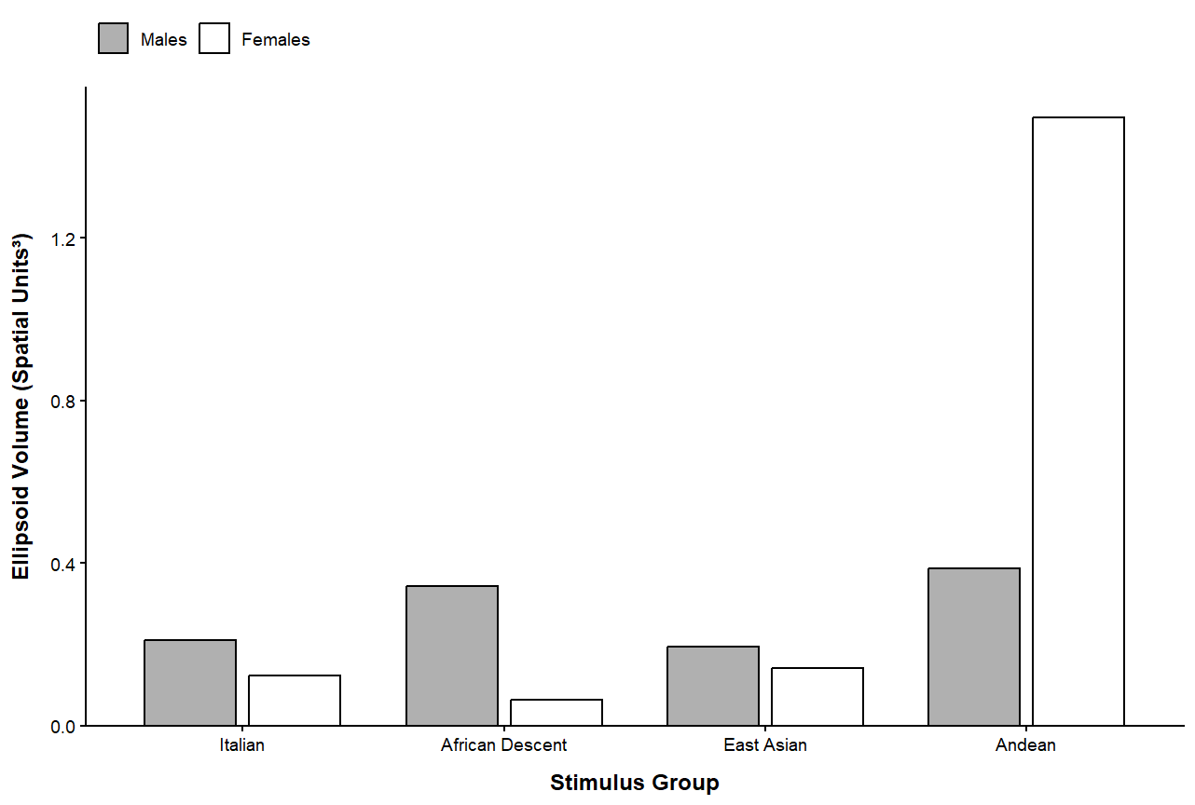
Note. Bar chart of 3D MDS ellipsoid volumes (Euclidean units³) across the four stimulus groups. Gray bars indicate male stimuli; white bars indicate female stimuli.

H2A. To spatially test H2A , the distances between group centroids in the 3D MDS space (in Table 2) were examined to determine whether outgroup centroids were clustered closer to one another than to the majority ingroup centroid. Consistent with the findings of S1, the data revealed that outgroups were not closer to one another than they were to the Italian ingroup. Replicating the pattern observed in S1, the African Descent group emerged as the most distant from all other groups, displaying larger mean distances across both male stimuli (M = 1.98) and female stimuli (M = 2.18). The hypothesis of a generalized tendency to perceive ethnic outgroups as spatially closer to one another seems not to be supported by the data collected in both studies.

Table 2
3D Centroid Distances for Male and Female Stimuli
Stimulus Gender | Group | 1 | 2 | 3 | 4
Male | 1. Italian | —
 | 2. African Descent | 2.173 | —
 | 3. East Asian | 1.213 | 2.198 | —
 | 4. Andean | 1.241 | 1.565 | 1.265 | —
Female | 1. Italian | —
 | 2. African Descent | 2.469 | —
 | 3. East Asian | 1.195 | 2.259 | —
 | 4. Andean | 1.499 | 1.824 | 1.124 | —
Note. Values indicate the 3D MDS centroid distances between the four stimulus groups in Euclidean units³.
Furthermore, S2 confirmed the consistent spatial mapping observed in S1 regarding the relative distances from the ingroup to the three outgroups (in Figure 8). For both stimulus genders, a clear and identical perceptual gradient emerged: East Asian stimuli were consistently perceived as the most similar to the Italian ingroup (distance = 1.21 for males; distance = 1.20 for females), followed by Andean stimuli (distance = 1.24 for males; 1.50 for females). Conversely, the African Descent faces were anchored as the most distant from the ingroup (distance = 2.17 for males; distance = 2.47 for females). Overall, the replication of the spatial pattern seems to suggest the presence of a robust, shared perceptual strategy for social categorization across both studies, providing a solid theoretical and geometric foundation for the subsequent statistical operationalizations.

Figure 8
3D MDS Spatial Distance of Minority-group Centroids from the Majority-group Centroid
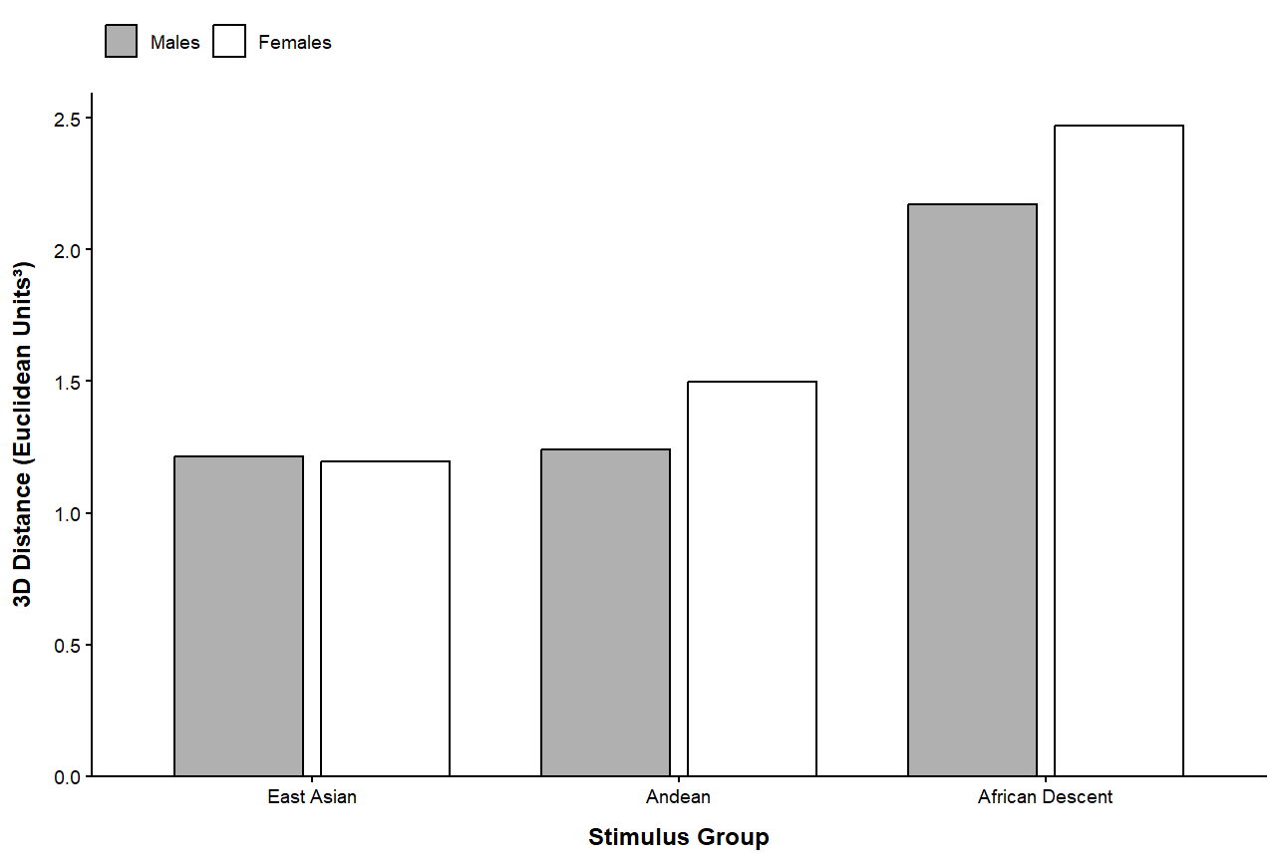
Note. 3D MDS spatial distance of minority-group centroids from the majority-group in Euclidean units³.

Statistical Analysis
Following the same analytical plan as S1, S2 applied the established LMM specification to complement the MDS findings, modeling perceived distance as a function of the Dyad Category (In-In, Out-Out, In-Out, Out1-Out2) × Age (mean-centered) interaction, controlling for participant gender. The model retained random intercepts for participant ID and stimulus images (left/right). Omnibus significance was evaluated via Type III ANOVA, while Hypotheses H1 (OHE) and H2 (minority-groups homogeneity effect) were tested using Estimated Marginal Means (EMMs) with 95% CIs for planned contrasts across dyad types, alongside age slope extractions to quantify developmental shifts (H1C, H2C).

H1A and H2A. The In-In category was established as the baseline for the model. Consistent with previous findings, significant differences emerged between the baseline and both the Out1-Out2 and In-Out dyads (i.e., the intergroup comparisons), b = 0.95, SE = 0.10, t(394.62) = 9.14, p < .001, and b = 0.90, SE = 0.10, t(394.61) = 8.64, p < .001, respectively. In contrast, no significant difference was observed between the baseline and the Out-Out dyads, b = -0.19, SE = 0.11, t(398.27) = -1.64, p = .102. These results were corroborated by pairwise comparisons conducted on the estimated marginal means (EMMs) using the Holm adjustment (see Figure 9). In an opposite way to OHE, the contrast between In-In and Out-Out was not significant (b = 0.19, SE = 0.11, z = 1.64, p = .202). Similarly the contrast between Out-Out and Out1-Out2 was significant (b = -1.14, SE = 0.07, z = -17.08, p < .001), not supporting the presence of a minority-groups homogeneity effect.

Figure 9
Perceived Distance by Category Dyad
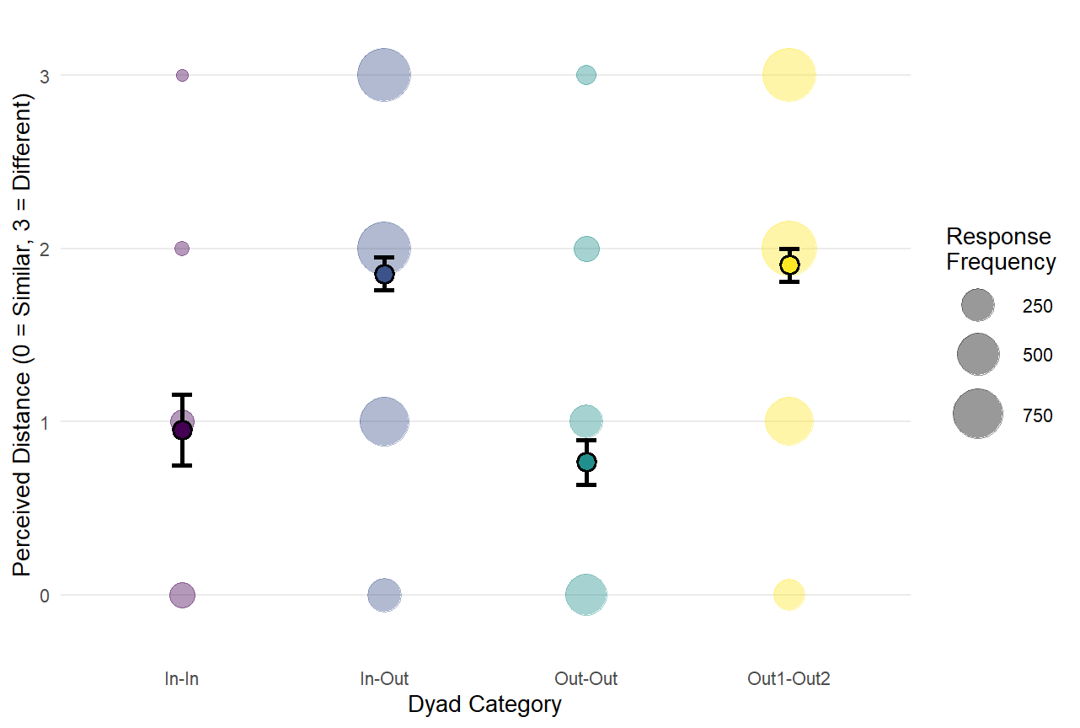
Note. Bubble plot displaying perceived distance ratings across four dyad categories. The size of each colored bubble corresponds to the response frequency for that specific rating. Solid points represent the mean perceived distance for each category, and error bars denote 95% confidence intervals.

H1B and H2B. Participant gender did not have a significant main effect on the perceived distance of the baseline In-In dyads, b = -.14, SE = 0.80, t(163.76) = -1.73, p = .09. As expected from hypotheses H1B and H2B, this lack of a significant gender effect was also confirmed by the Type III ANOVA, χ²(1) = 2.98, p = .08.

H1C and H2C. The objectives of H1C and H2C were to examine whether age influenced the OHE and the minority-groups homogeneity effect. In line with S1, the Type III ANOVA revealed a significant interaction between participant age and dyad category, χ²(3) = 51.97, p < .001. However, inspecting the LMM fixed effects, the overall developmental trend ran opposite to what suggested by the two effects. Specifically, as age increased, the perceived distance for intergroup categories grew significantly compared to the baseline, as indicated by the positive and significant interaction terms for In-Out (b = 0.17, SE = 0.04, t(6362.89) = 4.72, p < .001) and Out1-Out2 (b = 0.17, SE = 0.04, t(6362.64) = 4.79, p < .001) dyads. The interaction for Out-Out dyads, however, did not significantly differ from the baseline (b = 0.05, SE = 0.04, t(6349.82) = 1.32, p = .188). To examine this dynamic in detail, we analyzed the estimated marginal trends for each specific category (illustrated in Figure 10). For comparisons involving faces from two different groups, perceived distance significantly increased with age. In other words, older vs. young participants tended to perceive these faces as more distinct from one another, as suggested by the effect size and confidence intervals of the positive slopes for both In-Out dyads (b = 0.07, SE = 0.03, 95% CI [0.02, 0.12]) and Out1-Out2 dyads (b = 0.07, SE = 0.03, 95% CI [0.02, 0.12]). Conversely, as participants grew older, they perceived two ingroup faces as increasingly similar, evidenced by a significant negative trend for the baseline In-In category (b = -0.10, SE = 0.04, 95% CI [-0.18, -0.02]). The developmental slope for the Out-Out dyad also showed a slight downward trend (b = -0.05, SE = 0.03, 95% CI [-0.10, 0.01]), but since the confidence interval crossed zero, this effect was not statistically significant.
These findings align with S1, confirming a significant developmental trajectory where both intergroup dyad categories are perceived as increasingly different by older children. The absence of a significant slope for the Out-Out category is also consistent across both studies. The only element that did not replicate S1 is the trend and significance of the In-In slope, which in the present study exhibited the strongest significant decrease in perceived distance with age. This phenomenon, potentially linked to the specific contextual setting in which the two studies were conducted, will be addressed in the general discussion section.

Figure 10
Developmental Trajectories. Interaction Between Dyad Categories and Age
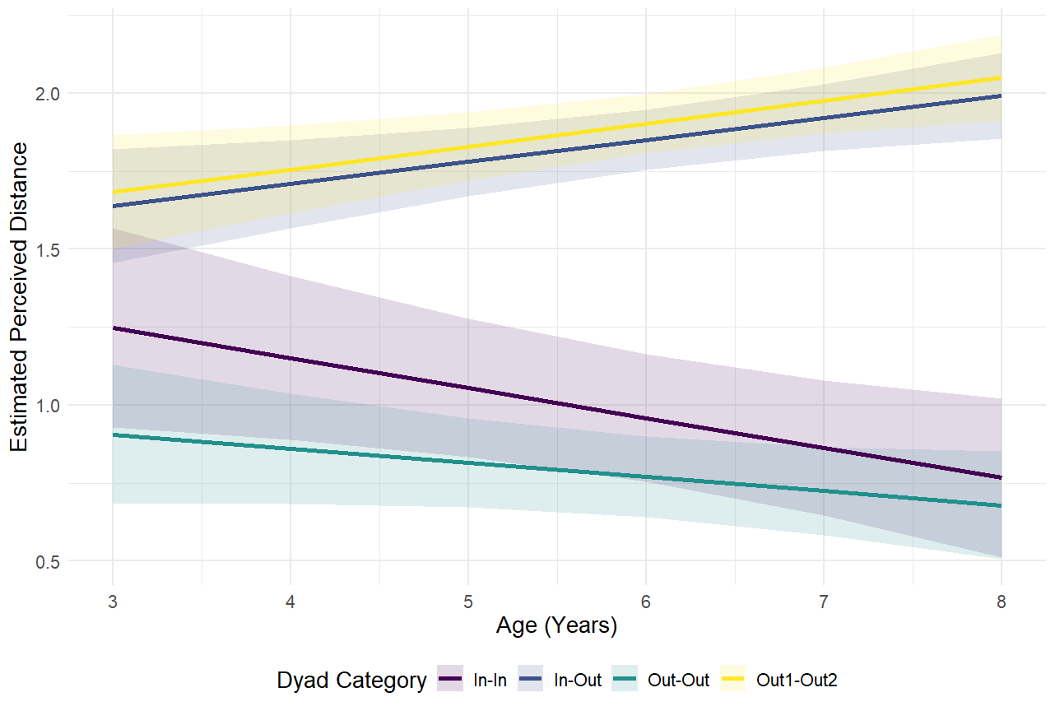
Note. Trajectories of the perceived distance between two faces across participants’ age for the four dyadic categories. The slopes represent the group relationships: In-In (purple), In-Out (dark blue), Out-Out (teal), Out1-Out2 (teal). Shaded bands around the regression lines indicate 95% confidence intervals.

Study 1 and Study 2

Spatial and Statistical Consistency
To evaluate perceptual mapping consistency across the two samples, a new 3D MDS was analysed, in which the S1 and S2 spatial configurations were superimposed using a symmetric Procrustes alignment (Correll et al., 2025; Hout et al., 2013). This technique mathematically translates, scales, and rotates one spatial map onto the other to maximize structural overlap, without altering the relative distances between stimuli within each independent dataset (Figure 11).

Figure 11
Procrustes 3D MDS Alignment (S1 vs S2) for Female and Male Stimuli
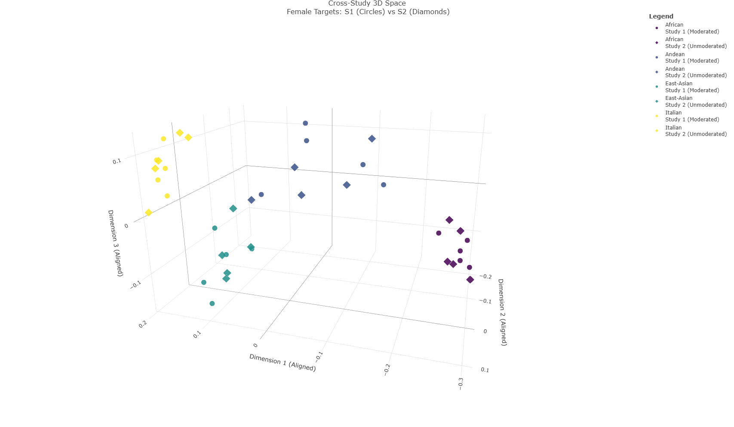
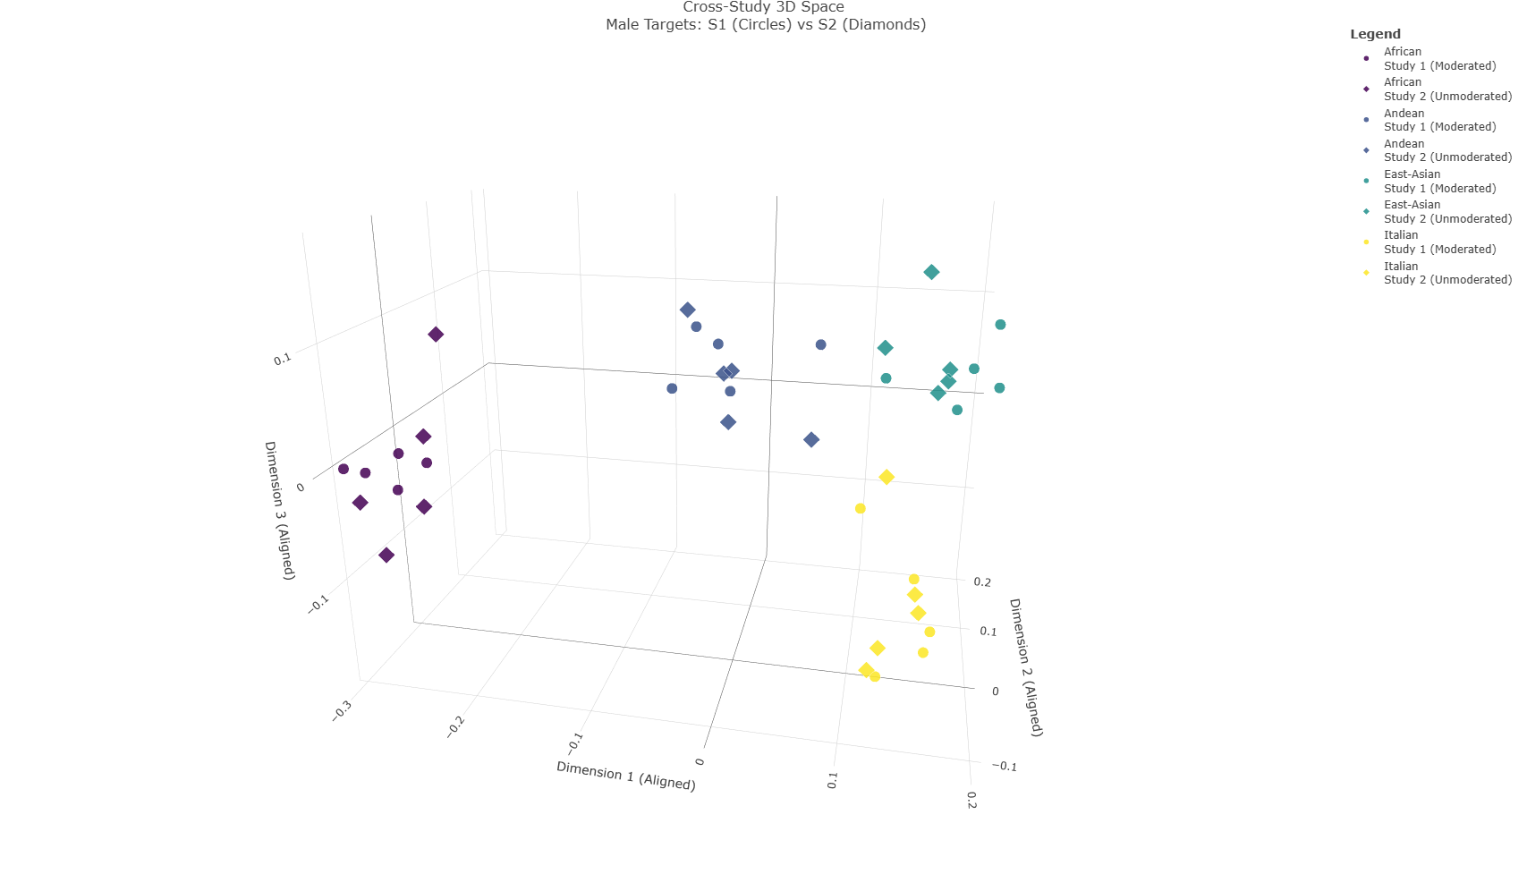
Note. 3D MDS spatial maps superimposing configurations from S1 and S2 using a symmetric Procrustes alignment for female targets (top panel) and male targets (bottom panel). Individual face stimuli of both S1 (circles) and 2 (diamonds) are represented by shape. Colors indicate the ethnic target group: African (purple), Andean (dark blue), East-Asian (teal), and Italian (yellow). The spatial proximity of corresponding circles and diamonds reflects the high structural replicability and minimal centroid shifting across the two independent samples.

Quantitative metrics confirmed a highly robust structural alignment, yielding high overall Tucker congruence coefficients across studies (ϕ = 0.934$ for males, ϕ = 0.950$ for females). The 3D Euclidean distances between corresponding ethnic group centroids across studies were small for African (males: 0.016, females: 0.004), Italian (males: 0.024, females: 0.014), East-Asian (males: 0.031, females: 0.027), and Andean (males: 0.060, females: 0.035) targets. Given that the maximum Euclidean distance within this space reaches 5.45, the largest observed centroid shift (0.060) accounts for 1.1% of the total spatial range, underscoring a practically indistinguishable mapping structure across studies.
To statistically confirm this replicability, we evaluated the structural consistency of the 20×20 perceptual distance matrices across the two samples. A Mantel test (999 permutations) revealed a strong, significant correlation between the perceptual structures for both female (r = .91, p = .001; BF10 = 3.89 × 10^69) and male (r = .87, p = .001; BF10 = 4.39 × 10^54) targets. Scatterplots of the pairwise perceptual distances (Figure 12) further illustrate this consistency across all intergroup and intragroup dyad combinations.
Figure 12
Structural Replicability: S1 vs S2. Correlation of Perceived Distances Across Two Independent Samples
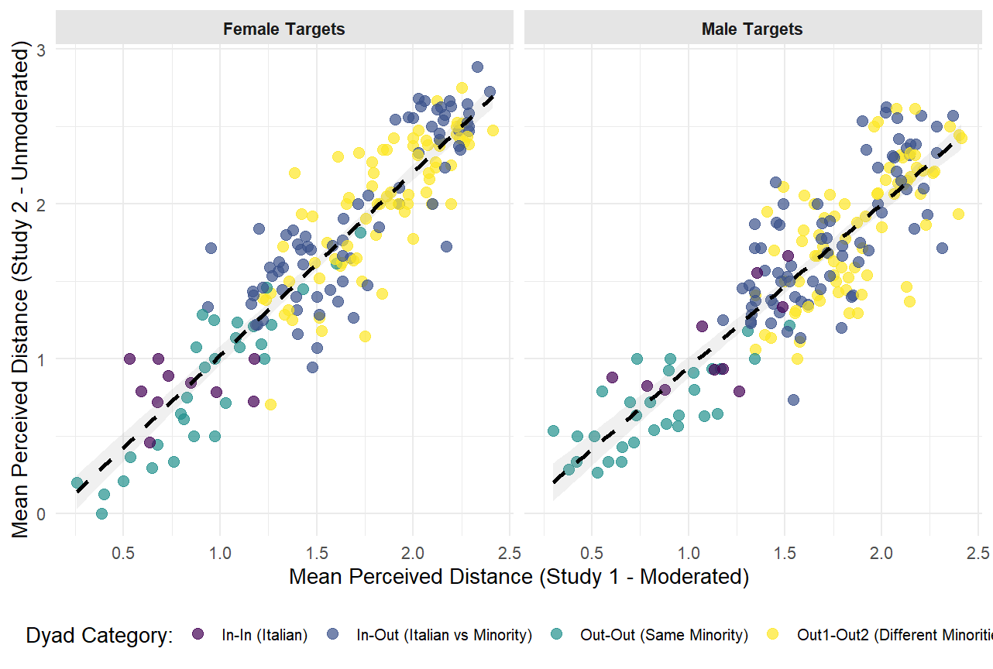
Note. Pairwise mean perceived distances in S1 vs. S2 for female targets (left) and male targets (right). Points represent individual stimulus dyads, color-coded by ethnic dyad category. Dashed lines represent linear regression trends with 95% confidence intervals (shaded regions).

Study 2 Discussion

General Discussion
- Synthesis of Findings: Confronto diretto tra i due studi.
- Theoretical Implications: Come i risultati ridefiniscono i modelli di percezione infantile, specialmente il legame tra entitatività ed essenzialismo visivo. Riprendere Introduzione: confermiamo risultati come Papesh e Golfnger oppure quelli sulla similarità (questi ultimi)? Inoltre, notiamo che in quei casi si usa solo il termine similarità, non si parla di omogeneità.
- Limitations and Future Directions: Limiti del paradigma. Numero di esposizioni a categorie di diadi iniquo. Ruolo della minaccia.
- Conclusion: Messaggio finale. Riprendere le implicazioni pratiche che potrebbe avere l’immigrazione di massa discussa a fine introduzione. Interventi nelle scuole.

